**Spring Shower Almond Petits Fours**

* yield: Makes 30

51

[Fave it](https://my.marthastewart.com/access-denied?destination=http%3A//www.marthastewart.com/312747/spring-shower-almond-petits-fours%23save-to-collection&site_code=mslo)

|  |  |  |  |  |  |  |
| --- | --- | --- | --- | --- | --- | --- |
|  | |  |  |  |  |  | | --- | --- | --- | --- | --- | | |  |  |  | | --- | --- | --- | |  | http://www.marthastewart.com/sites/all/modules/custom/mslo_social/images/pin_off.png |  | | 990 | |

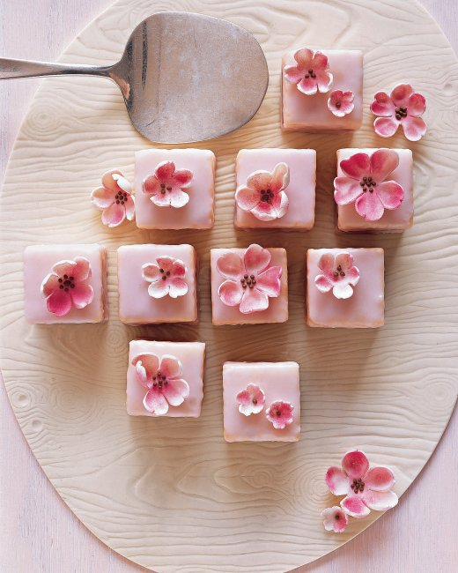

**Get More**

[Subscribe to Our Magazines](http://www.marthastewart.com/customer-service) [Sign Up for Our Newsletters](https://my.marthastewart.com/newsletter-subscribe)

<SCRIPT language='JavaScript1.1' SRC="http://ad.doubleclick.net/adj/N9269.1355588.DOUBLECLICK.COMBI3/B7824429.4;abr=!ie;sz=300x250;dbmio=1149045;dbmcid=1277497;dbms=www.womensinterest.com;u=xbAAXbk6pC0yoSxP1S6uRB25Oq4gYqHupBFfvxHSm3f2Pj0S_XuKpagP6ngdlgmuGtRIqR9TIuP0cLkQDHIbr3c2RiP4Daq_dLXg;ord=1377192220?"> </SCRIPT> <NOSCRIPT> <A HREF="http://ad.doubleclick.net/jump/N9269.1355588.DOUBLECLICK.COMBI3/B7824429.4;abr=!ie4;abr=!ie5;sz=300x250;dbmio=1149045;dbmcid=1277497;dbms=www.womensinterest.com;u=xbAAXbk6pC0yoSxP1S6uRB25Oq4gYqHupBFfvxHSm3f2Pj0S_XuKpagP6ngdlgmuGtRIqR9TIuP0cLkQDHIbr3c2RiP4Daq_dLXg;ord=1377192220?"> <IMG SRC="http://ad.doubleclick.net/ad/N9269.1355588.DOUBLECLICK.COMBI3/B7824429.4;abr=!ie4;abr=!ie5;sz=300x250;dbmio=1149045;dbmcid=1277497;dbms=www.womensinterest.com;u=xbAAXbk6pC0yoSxP1S6uRB25Oq4gYqHupBFfvxHSm3f2Pj0S_XuKpagP6ngdlgmuGtRIqR9TIuP0cLkQDHIbr3c2RiP4Daq_dLXg;ord=1377192220?" BORDER=0 WIDTH=300 HEIGHT=250 ALT="Advertisement"></A> </NOSCRIPT>

**Ingredients**

* 6 tablespoons unsalted butter, softened, plus more for baking sheet
* 1 1/4 cups cake flour (not self-rising), plus more for baking sheet
* 3/4 teaspoon baking powder
* 1/4 teaspoon baking soda
* 1/4 teaspoon salt
* 1 cup sugar
* 1/2 cup almond paste
* 4 large eggs, separated
* 1/2 teaspoon pure vanilla extract
* 1/2 cup whole milk
* 1/2 cup cherry preserves, processed in a food processor
* [Sugar Glaze](http://www.marthastewart.com/282861/sugar-glaze)
* Gum paste cherry blossoms, (available at Wendy Kromer Confections)

**Directions**

1. **Step 1**

Preheat oven to 350 degrees. Butter a 12-by-17- inch rimmed baking sheet, and line with parchment paper. Butter parchment, and dust with flour, tapping out excess; set aside. Sift flour, baking powder, baking soda, and salt into a large bowl; set aside.

1. **Step 2**

Put 3/4 cup sugar and the almond paste into the bowl of an electric mixer fitted with the paddle attachment. Mix on medium-low speed until mixture resembles coarse meal, about 2 minutes. Raise speed to medium-high. Add butter; mix until pale and fluffy, about 2 minutes. Mix in egg yolks and vanilla. Add flour mixture in 2 batches, alternating with the milk. Transfer to a large bowl; set aside.

1. **Step 3**

Put egg whites into the clean bowl of an electric mixer fitted with whisk attachment; beat on medium-high speed until foamy. Gradually add remaining 1/4 cup sugar, beating until soft peaks form. Fold one-third of egg-white mixture into batter with a rubber spatula. Gently fold in remaining egg-white mixture.

1. **Step 4**

Spread evenly into prepared sheet. Bake until a cake tester inserted into center comes out clean, 15 to 20 minutes. Transfer sheet to wire rack; let cool completely. Unmold; remove parchment.

1. **Step 5**

Cut cake in half crosswise. Spread one half with preserves; top with remaining half. Refrigerate 1 hour. Trim cake, and cut into 11/2-inch squares. Transfer to a wire rack set over a rimmed baking sheet. Pour glaze over each petit four, spreading over top and sides to coat completely. Reuse glaze, straining to remove any solids, if needed. Refrigerate until set, about 20 minutes. Garnish with blossoms. Cakes can be refrigerated up to 2 days.